

Automation Technology 1

Automation Booklet 1: Simple and Advanced Sequencing
Lecturer: Eoin Byrne
Submission Date: N/A

Section 1 – Simple Sequencing Ladder Logic

Objective:
To gain practical experience constructing simple sequencing ladder diagrams. Gain Proficiency programming a PLC using simple logic functions.

Instructions:
- Construct a ladder diagram for each of the circuits shown below. Create a new diagram for each circuit.

- Test the ladder logic to ensure there are no errors or warnings.

- Design an Appropriate Wiring Diagram for Each Problem Scenario

PLC Problem 1:
A Three Phase industrial Mixer is Required to Mix contents in a large 1000Ltr holding tank.

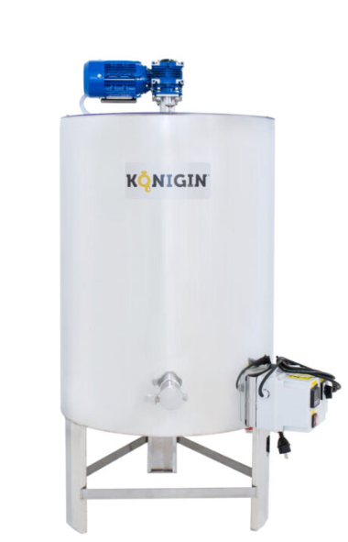

(Thermal Overload is Omitted)
The operation is required as follows:
1: Once the start Button is Pressed a 5 second Delay timer is required before the Process Starts.
2: On Activation of the Start Button the Green LED Should flash on the signal control station and once the Motor is activated the LED should then Stay On.
3: If the Motor isn’t activated or on the Red LED Should be Luminated
4: If at any point in the Process and Operator Opens the hatch on top of the holding tank the process comes to an immediate stop.
M8013
Requirements:
1: Design the Ladder Diagram for the Process Required
2: Develop the Instruction List for the Process. Aqui vale con escribirlo en un CSV desde el propio programa
3: Design the Wiring Diagram for the Process
4: Develop a full Explanation of how the PLC Program Operates.
Cuando X0 es un contacto NO, que al ser activado, en su flanco de subida este configura M0, el cual se encarga de energizar el sistema. Durante la Segunda linea se ha configurado X1, el cual se trata de un contacto NO que de la misma forma, durante el flanco de subida reseteara M0 satisfaciendo asi que la condicion de que si un operador abre el hatch este corte la energia inmediatamente.
Una vez que M0 es configurado (set), empieza un temporizador (T0) de 5 segundos que retrasara el inicio del proceso. Para que el motor se encienda necesita dos condiciones, que T0 este energizado y que M0 este set, por lo tanto, hasta que no pasen los 5 segundos, el motor no se encendera.
Durante estos 5 segundos se establecera un LED verde que parpadeara de forma intermitente y una vez que el motor se encienda se mantendra encendido. Para el parpadeo se usa una logica de tipo AND donde se deben cumplir 3 requisitos, un contacto NO de M0 debe estar set, se debe colocar un contacto NO M8013 (el cual se encarga de dejar pasar energia de forma intermitente) y un contacto NC del contacto del motor para asegurarse de que parpadee cuando aun no se enciende el motor (Y0). Toda esta logica AND a su vez esta ligada a una logica OR con un contacto NO del motor (Y0) para que se mantenga encendido el led verde una vez que el motor este encendido.
Finalmente, se coloco un contacto NC del motor (Y0) conectado a un LED rojo (Y2) para satisfacer el requisito de que este LED este encedido cuando Y0 esta apagado o desactivado.
PLC Problem 2:
A Conveyor belt is employed to sort out Blue and yellow Lego Bricks due to a previous malfunction with the vision sorting system. The temporary solution consists of a conveyor belt with a hopper at the end which will house the blue Lego and a hopper of the side which will house the yellow Lego bricks. A colour sensor sits above the conveyor and once running the pneumatic ram will only allow sorting.
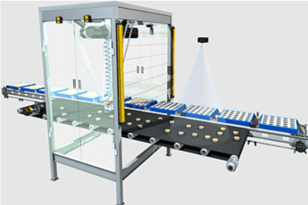
Operation:
1: One Activation of a start push button the Conveyor motor will power on and the sorting process can begin.
2: When the Machine is Active a Green LED is Luminated
3: When the Machine is off the Red LED is Luminated
4: If the Conveyor motor overloads due to a Material Jam or damaged motor an orange LED will Flash and the system will stop.
5: If the colour sensor detects a Yellow brick the cylinder should extend until it hits the reed switch. There should be a delay of retracting the cylinder back to its home position by a 5s interval. (Coil Activated Spring Return DCV) Pneumatics should only kick in when the conveyor motor is running
6: On 100 Cycles if a yellow brick is detected the system should shut off. This will enable the operator to change the small hopper and ensure the operator supervises the batch.

Requirements:
1: Design the Ladder Diagram for the Process Required
2: Design the Wiring Diagram for the Process
3: Develop a full Explanation of how the PLC Program Operates.

PLC Problem 3:

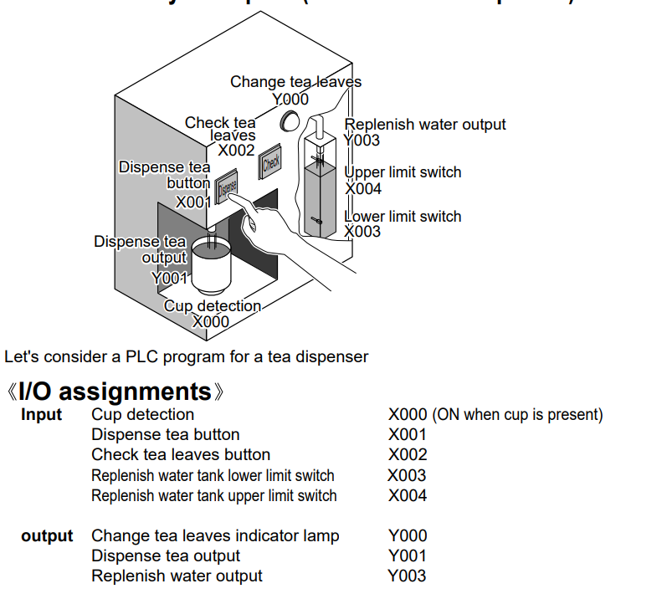

Process Automation:
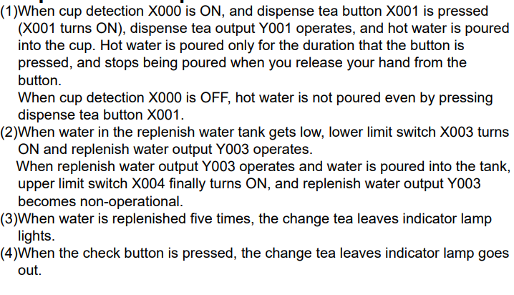

Requirements:
1: Design the Ladder Diagram for the Process Required
2: Design the Wiring Diagram for the Process
3: Develop a full Explanation of how the PLC Program Operates.

PLC Problem 4:
An Industrial Process is controlled by a PLC. The process is as follows,
1: The process is started via start button (X0) and can be stopped at any point in the process by pressing the stop button (X1)
2: An indicating LED, indicates when the process is running. (Y0)
3: When the start button is pressed, water enters the vessel via valve V1(Y1) and fills until it reaches the max level sensor (X4).
4: When the liquid reaches the Max level sensor (X4) valves V1 (Y1) closes. Valve V2 (Y2) opens and drains the tank.
5: When the low-level sensor (X3) IS reached V2 (Y2) Closes.
6: The sequence will repeat until the stop button is pressed.
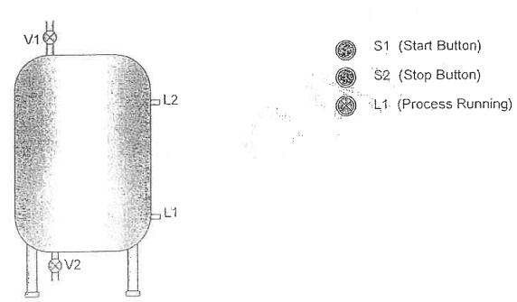
Requirements:
1: Design the Ladder Diagram for the Process Required
2: Design the Wiring Diagram for the Process
3: Develop a full Explanation of how the PLC Program Operates.

PLC Problem 5:

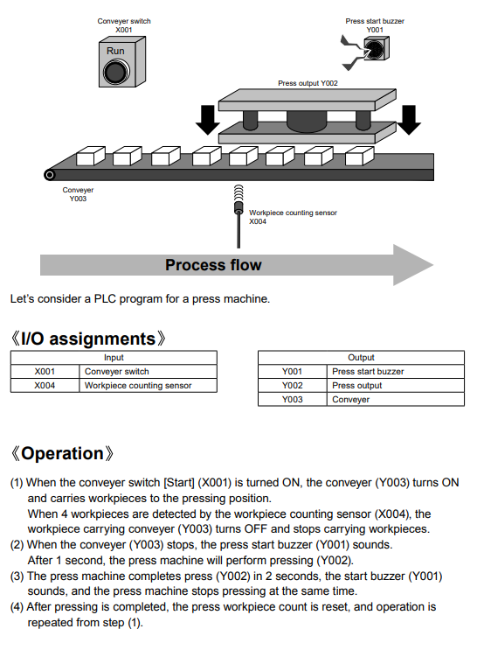

Requirements:
1: Design the Ladder Diagram for the Process Required
2: Design the Wiring Diagram for the Process
3: Develop a full Explanation of how the PLC Program Operates.
PLC Problem 6:

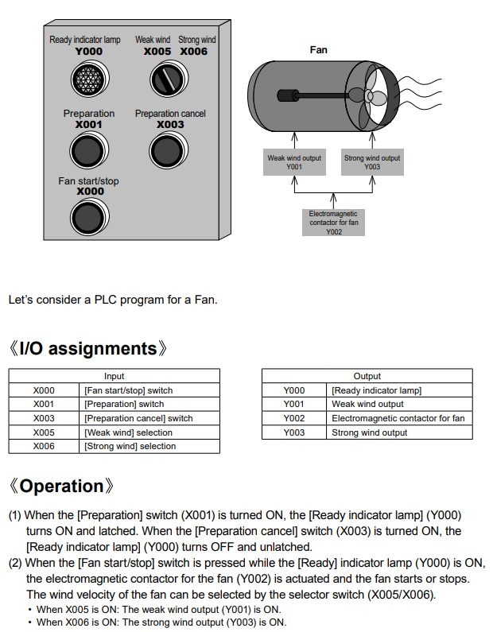

PLC Problem 7:
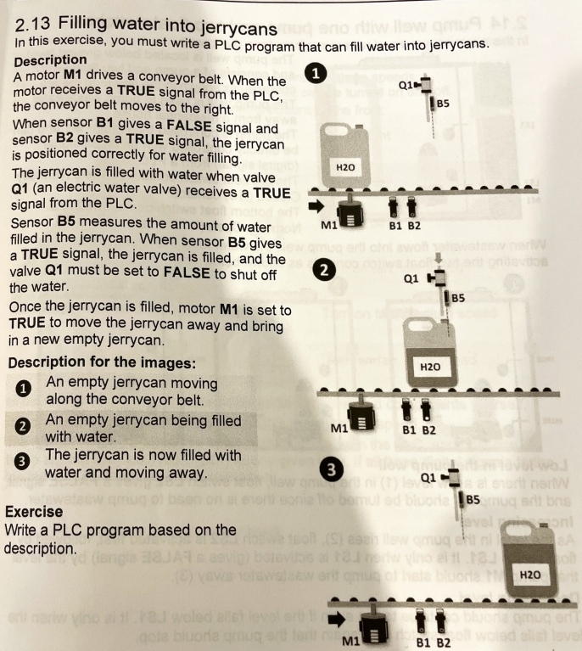

Requirements:
1: Design the Ladder Diagram for the Process Required
2: Design the Wiring Diagram for the Process
3: Develop a full Explanation of how the PLC Program Operates.

PLC Problem 8:
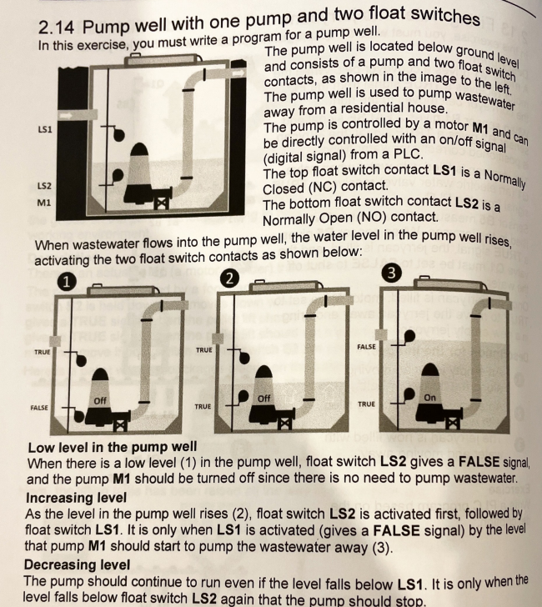
Requirements:
1: Design the Ladder Diagram for the Process Required
2: Design the Wiring Diagram for the Process

PLC Problem 9:

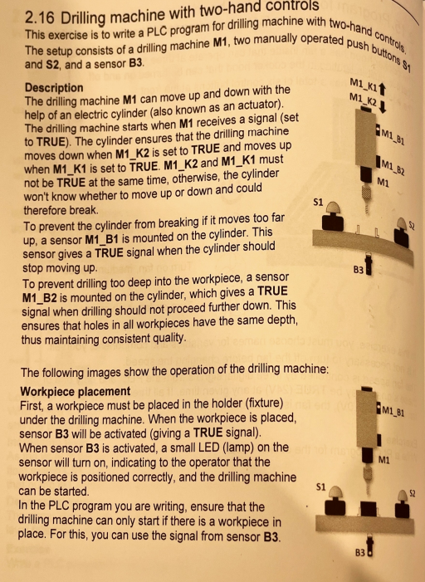

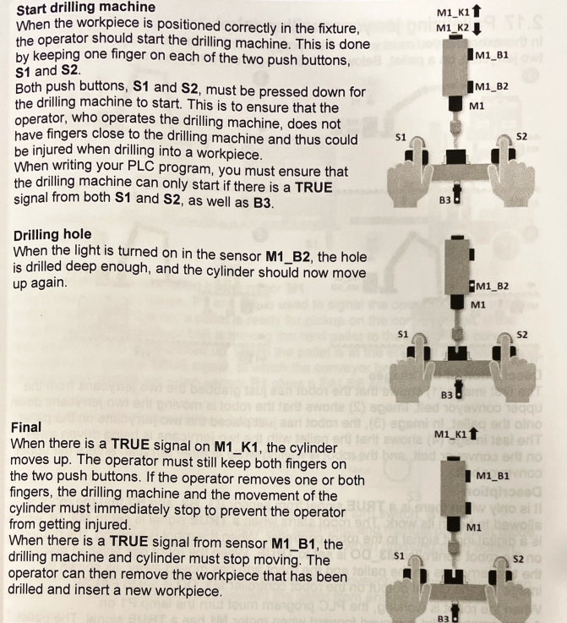

Requirements:
1: Design the Ladder Diagram for the Process Required
(N.B Safety Relay to be integrated)
2: Design the Wiring Diagram for the Process

